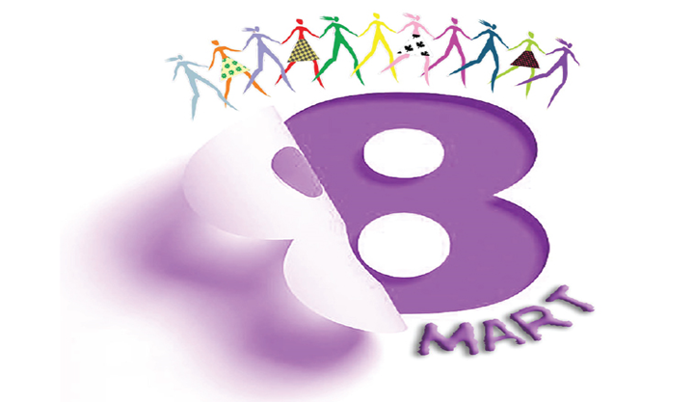

Beloved Sisters,
The feeling of disappointment when it is learnt that the coming baby is a girl while we are in a mother's womb could be the first example of discrimination that we will come across throughout our lives.
Having the identity of a woman inspires our struggle despite all the difficulties. All over the world, existence of women organizing protests, opening institutions against the slaughter of our sisters, being raped, and facing the exploitation of labour, wars, make us feel strong in the streets amid walking through the darkness of the night.
Speaking more on the rights of women and the messages given for being heard more on the international platforms and the protests held are precious steps for the freedom of women.
Male dominant capitalist system exploits our labours, our body and our identity. Violence against women, harassment, rape and attacks on female body are increasing day by day. We greet our sisters, who organize the strike with the power of woman solidarity, saying "Enough is enough!" in different countries of the world.
We know that we, as women, will make the world beautiful and liberate.

Women Secretary
Derya YULCU
